# **Analysing Pre-Order Decline on Electric Vehicle Manufacturer's Website**

**Domain – Automotive Tool Stack Used – MySQL**

# **Introduction**

**Zoom Electric** (ZE) is an electric automotive venture of a leading automotive manufacturer **ZOOM MOTORS India Private Limited.**

You are working as an analyst in the sales & operation team at **Zoom Electric**. The team is responsible for executing the pre-orders, sales client visits, website sales, and analyse the visit session created on the website and analyse the sales funnel.

Zoom Electric has automotive and scooters as its product line - FioNex, Sprint, and Parker and its Limited Editions are some of its premium scooter variants.

# **Problem**

ZE has introduced a new scooter variant, Sprint in the 2-wheeler EV scooter segment. Initially Sprint Scooters' sales numbers were quite impressive in the first two weeks of launch but suddenly it started decreasing unexpectedly.

As a data analyst, you have been assigned to validate the sales drop for Sprint scooters and figure out the reasons for this decline.

# **Implications**

The decline in sales led to decrease in Revenue.

# **Objectives**

* Find out why sales of the Sprint scooter declined.
* Calculate sales volume growth % in a specific time period.
* Compare the growth % of Sprint with Sprint Limited Edition.
* Calculate the email opening rate and click through rates and compare it with industry benchmarks.

# **Solutions**

# **1. Validating the Problem**

**Quantifying the sales drop: Sprint Scooter & comparing with others**

The growth in sales volume experienced a decrease two weeks following the launch of the **Sprint**scooter. Despite a promising start in the first two weeks, sales began to decline by 20 % thereafter.

“Validate *that sales has declined”* means calculating sales growth % (*or more precisely sales volume growth %*) in a specific time period.

I Created a table to summarize the **Sales Volume & Growth**for the initial 22 days (a little over 3 weeks) as the sales were reported to drop after the first two weeks.

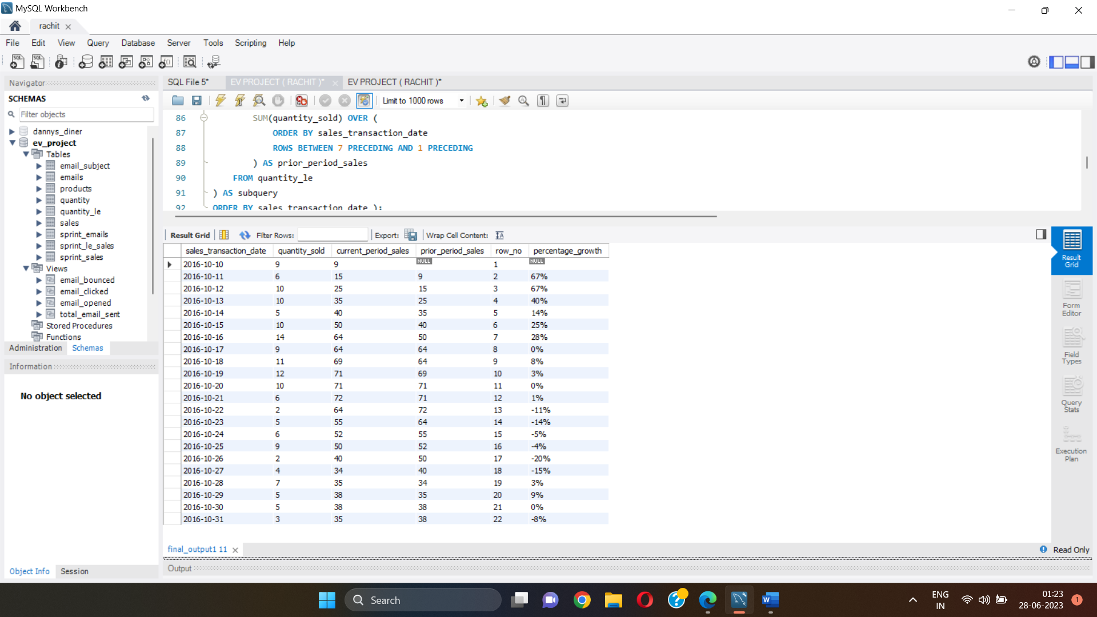

Column Description:

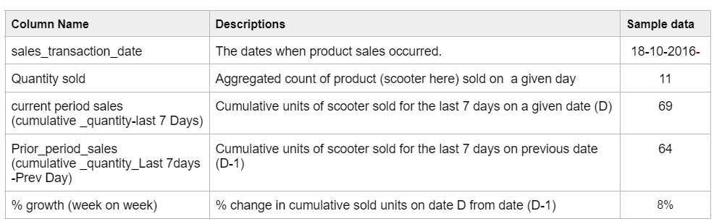

2. Launch Date Hypothesis

Analysing reason for sales decline

Launch date assumption

Zoom Electric used to launch its product usually in the first half of the year, Sprint is the only scooter which was launched in the second half of the year (in the month of October).

I Compared the growth % of Sprint with Sprint Limited Edition that was launched on different dates.

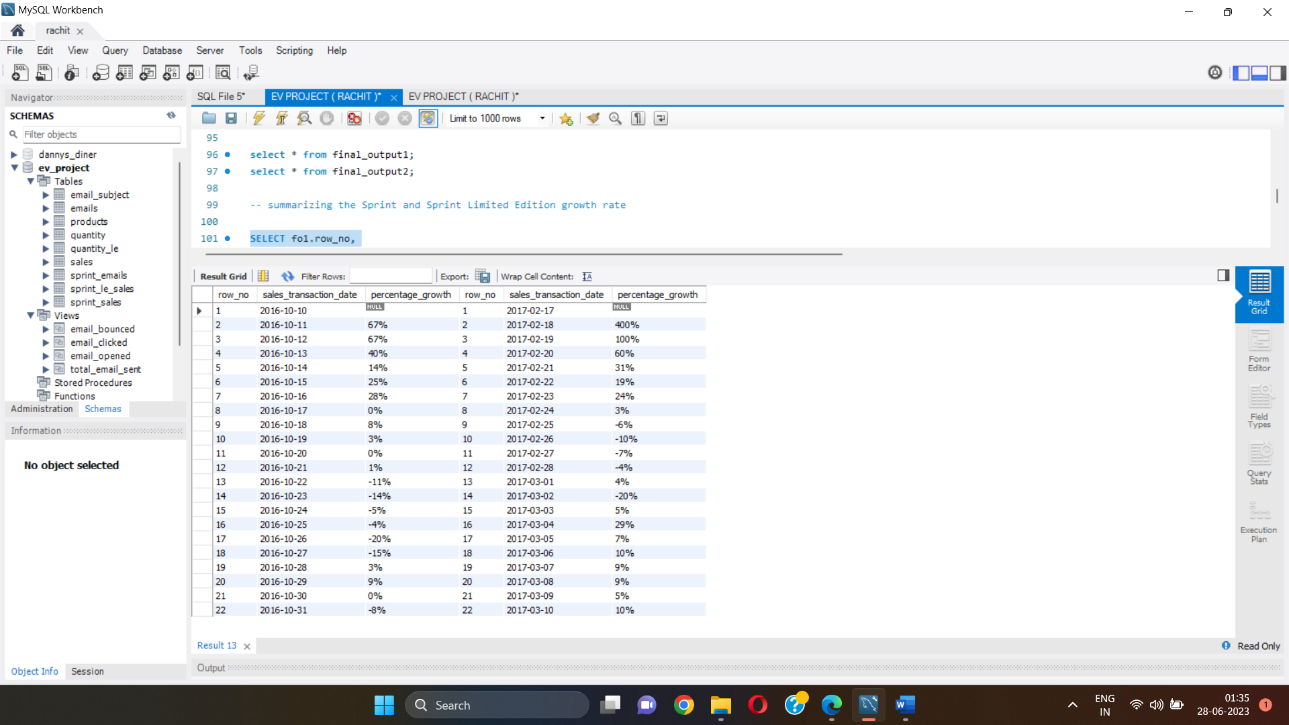

3. Email Analysis

Analysing reason for sales decline

Email campaign

For analysing email campaign and its impact on sales growth:

I took the emails data for Sprint scooter only

Data should be only for the period of 2 months before sprint model launch (digital marketing campaign started only 2 months before launch) and

After receiving an email from ZE, customers have either opened it or not, then clicked the email or not.

I calculated the email opening rate and click through rates,

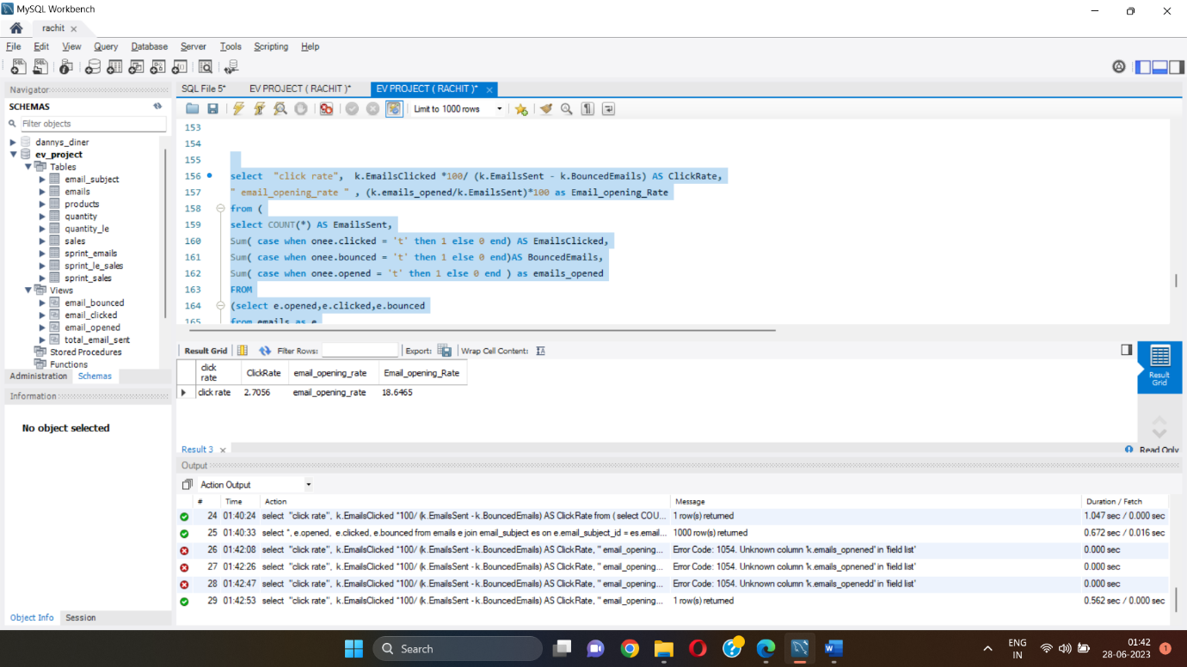

Typically, the industry benchmark for a quality campaign is - **18%** email opening rate,**8%** CTR.

If campaign’s email opening rate and CTR is below benchmark, you can say that sprint campaign doesn't have much impact.

I Prepared the summary table that shows the comparison between the calculated email opening rate & CTR against the benchmark rates.

|  |  |  |
| --- | --- | --- |
|  | Benchmarks Rates | Calculated Rates |
| Click Through Rates | **8 %** | **2.7 %** |
| Email Opening Rates | **18 %** | **18.6 %** |

INSIGHTS

* Sales of sprint scooter dropped on the 13th day after being launched
* Sprint was launched in the month of October and Sprint Limited Edition was launched in the month of February.
* Sales of sprint limited edition scooter dropped on the 9th day after being launched. This proves that Launch date doesn’t affect the sales volume and growth.
* Email Opening Rate are little above the benchmark rate which shows that email marketing campaigns do have an impact on the sales volume growth of the sprint Electric Scooter.